
LESSON NOTE | DETAILED EXPLANATORY NOTES
POPULATION ECOLOGY
HUMAN IMPACT ON ECOSYSTEMS & CLIMATE CHANGE MITIGATION
GRADE 12 - BIOLOGY
■ ■ ■

People and the Living World
Humans depend completely on ecosystems for food, water, air, medicine and materials. But as the human population and its use of resources have grown, our activities have put ecosystems under great pressure. Human impact on ecosystems includes deforestation, pollution, overexploitation, habitat loss and, above all, climate change. The good news is that we can also take action to reduce this damage - through conservation and climate change mitigation.
This lesson describes the main ways humans affect ecosystems, explains climate change and its causes and effects, and outlines what can be done to mitigate it - with a focus on Papua New Guinea. It draws together the Population Ecology strand, applying ideas about populations, energy flow and interactions to real environmental problems.
Why This Matters
- Human survival depends on healthy ecosystems.
- Climate change is the biggest environmental challenge of our time.
- Our choices can either harm or protect the environment.
- PNG's forests, reefs and low-lying islands are especially vulnerable.
Human Impact on Ecosystems & Climate Change Mitigation
Key Learning Outcomes
By the end of this lesson, students should be able to:
- Describe the main ways humans affect ecosystems.
- Explain climate change, its causes and its effects.
- Explain the greenhouse effect and the role of greenhouse gases.
- Describe strategies to mitigate climate change and protect ecosystems.
- Relate these issues and actions to Papua New Guinea.
How Humans Affect Ecosystems
A growing human population puts many pressures on ecosystems. Deforestation - clearing forests for farming, timber and settlement - destroys habitats and releases stored carbon. Pollution contaminates the air, water and soil with chemicals, plastics and waste. Overexploitation - such as overfishing and overhunting - removes species faster than they can reproduce. Habitat loss and fragmentation leave species with nowhere to live, reducing biodiversity. And burning fossil fuels drives climate change, which affects every ecosystem on Earth. These impacts often act together, making the damage worse.
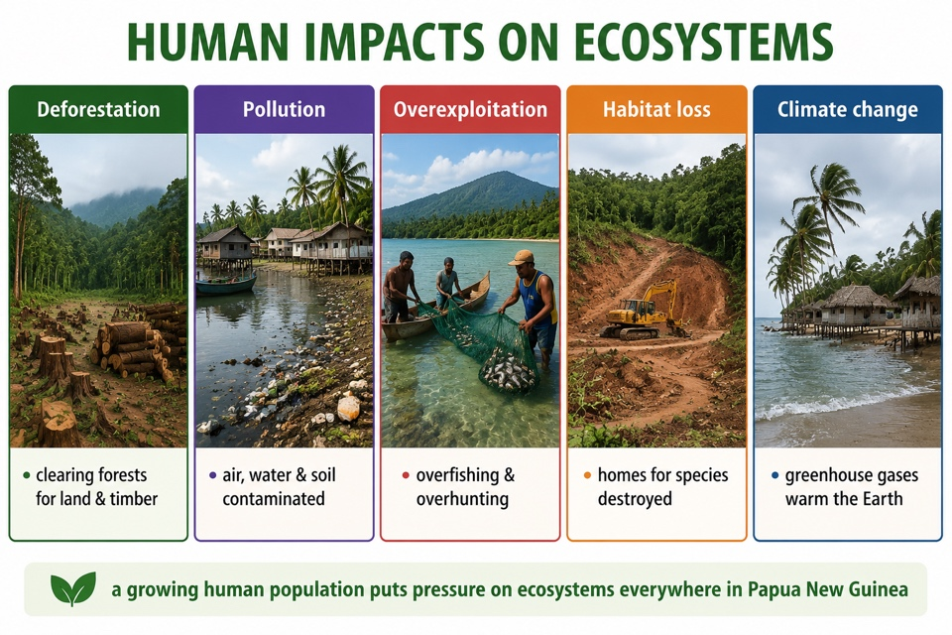
Figure 1: The main ways human activity affects ecosystems, from deforestation to climate change.
Terminologies and Concepts
Useful terms for this topic:
- Ecosystem: a community of living things and their physical environment.
- Deforestation: the clearing or removal of forests.
- Pollution: harmful substances released into the environment.
- Biodiversity: the variety of living things in an area.
- Greenhouse gases: gases (CO₂, methane) that trap heat in the atmosphere.
- Climate change / global warming: long-term change in climate; rising average temperature.
- Mitigation: actions that reduce harm and slow climate change.
- Sustainability: using resources without using them up for the future.
Climate Change and the Greenhouse Effect
Some gases in the atmosphere - carbon dioxide (CO₂), methane and others - act like the glass of a greenhouse: they let sunlight in but trap heat, keeping the Earth warm enough for life. This natural greenhouse effect is essential. The problem is that human activities - burning fossil fuels and clearing forests - have greatly increased these gases, trapping extra heat. This causes global warming: a rise in the Earth's average temperature. The effects include melting ice, rising sea levels, more extreme weather (floods, droughts, stronger storms), and disruption to ecosystems and food supplies.
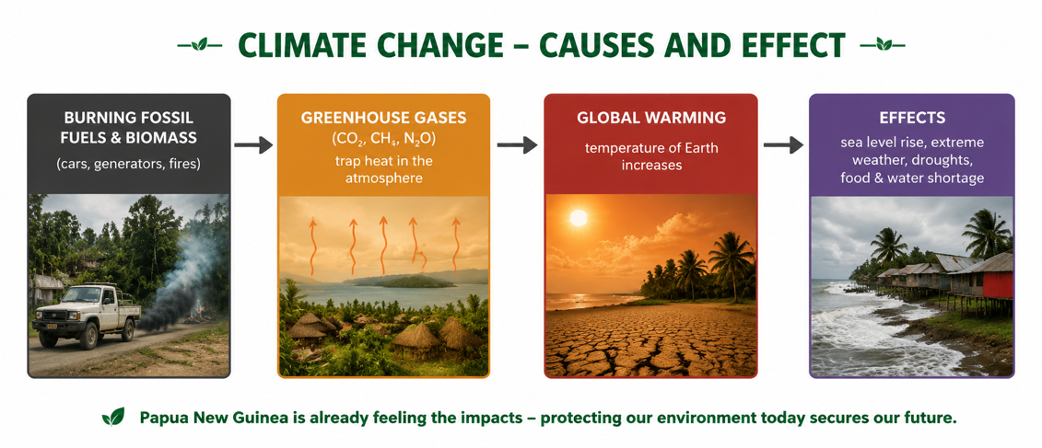
Figure 2: Climate change - burning fossil fuels adds greenhouse gases that trap heat and warm the planet.
Mitigation - Reducing Our Impact
Mitigation means taking action to reduce harm and slow climate change. Key strategies include switching to renewable energy - solar, hydro, wind and bioenergy - instead of fossil fuels; reforestation (planting trees), which absorbs CO₂ and restores habitats; and reduce, reuse, recycle to cut waste and pollution. Protecting habitats through national parks and marine reserves preserves biodiversity, while sustainable use - farming, fishing and logging within safe limits - lets resources renew themselves. Individuals help too, by saving energy, planting trees and reducing waste. Together, these actions can lessen our impact on the planet.
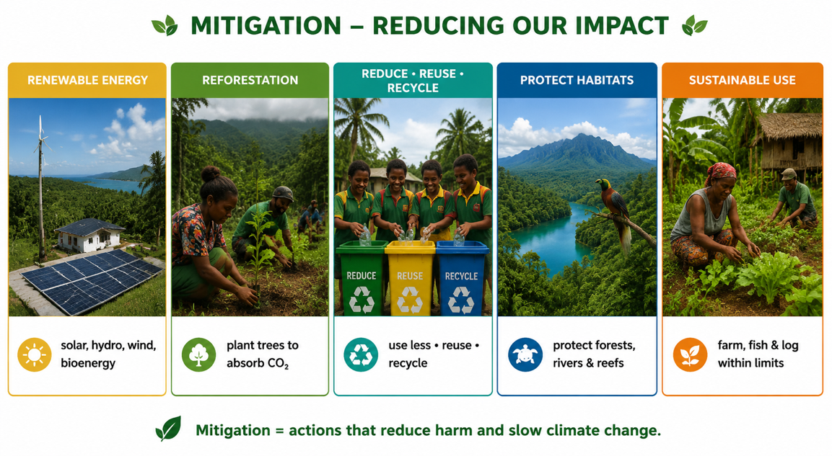
Figure 3: Mitigation strategies - from renewable energy and reforestation to protecting habitats and sustainable use.
Conservation and Adaptation
Alongside mitigation, we also need conservation and adaptation. Conservation protects species and habitats - through protected areas, replanting, controlling hunting and fishing, and captive breeding of endangered species. Adaptation means adjusting to the changes already happening - for example, building flood defences, planting drought- and salt-tolerant crops, and moving communities away from rising seas. Mitigation tackles the causes of climate change, while adaptation helps people and ecosystems cope with its effects. Both are needed, and both work best when governments, communities and individuals act together.
Why This Matters
- Survival - healthy ecosystems provide our food, water and air.
- Climate - mitigation is essential to limit dangerous warming.
- Biodiversity - conservation protects the variety of life.
- Responsibility - everyone can take action to protect the environment.
PNG Context Example
Papua New Guinea is both rich in nature and highly exposed to these problems. Its vast rainforests are a globally important carbon store, so logging and forest clearing release greenhouse gases and destroy habitats - making sustainable forestry and reforestation vital. PNG's coral reefs are threatened by warming seas and pollution, affecting the fish people rely on. Low-lying islands and coastal communities are already facing rising sea levels, forcing some to relocate. PNG can respond by developing renewable energy (hydro, solar and bioenergy), protecting forests and reefs, using resources sustainably, and helping communities adapt - protecting both its people and its extraordinary biodiversity.
References & Related Documents
Source Documents
- PNG Biology Syllabus (SBC), Grades 11 & 12 - Strand: Ecology / Population Ecology; investigate human impacts on ecosystems and evaluate strategies for conservation and climate-change mitigation.
- STEM Biology Syllabus - Grade 12. Thema: Ecology; Module: Population Ecology - Human Impact & Sustainability. Department of Education, PNG.
Further Reading & References
- OpenStax Biology - The Biosphere and Human Impacts; Threats to Biodiversity; Climate Change. https://openstax.org/books/biology
- IPCC / UNEP - Climate change: causes, impacts and mitigation (summaries for education). https://www.ipcc.ch

